The Dysart Community Directory
The aim of the Dysart Community Directory on the Dysart Community Support Group website, is to create a link between community, business and services. This one stop site will offer customers, clients, residents and fellow business operators the ability to search and find products and services within the local community. A link to your own business website/Facebook page can be set up on the directory, putting customers in contact with you instantly.
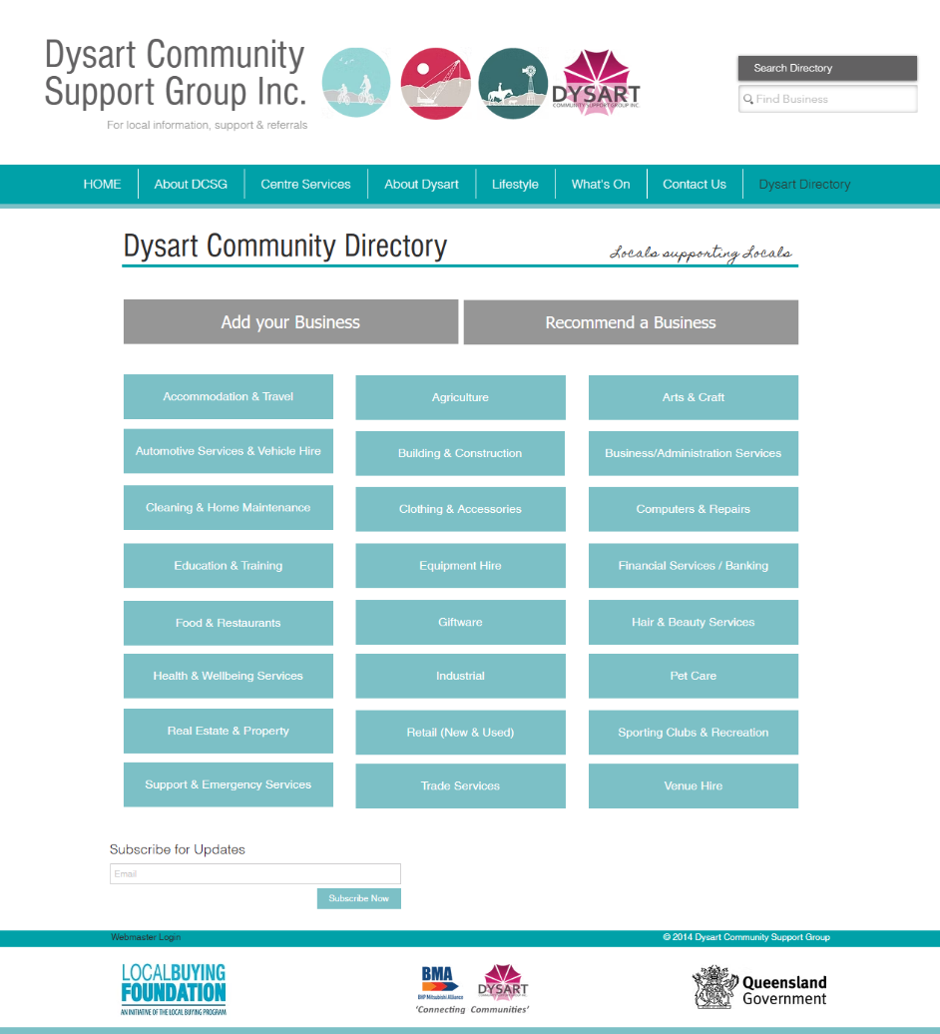

Residents can use the search bar in the header to search your business name and find your full listing. Alternatively, they can head to the Dysart Community Directory page to identify the category of business they are seeking.

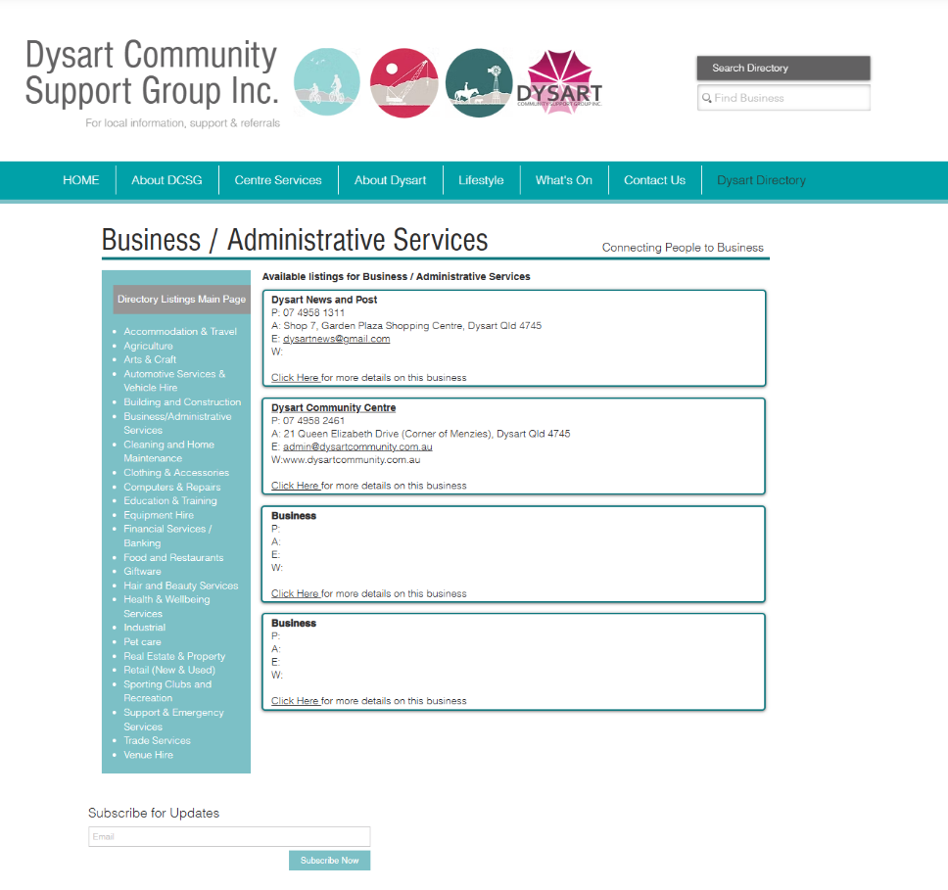

After clicking the category, they will be presented with all the listings that sit within that category on the quick contact page. If they are seeking further information about a business, they can click into their full listing.

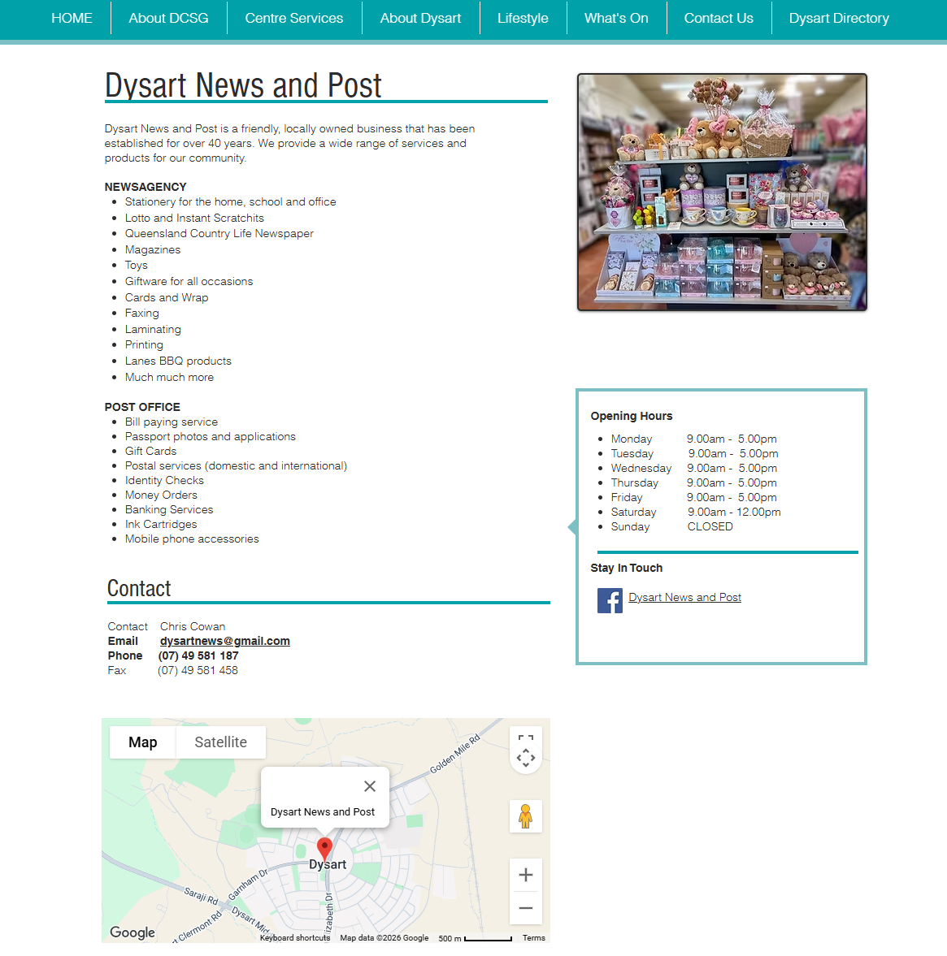
Below is an example on how your full directory listing will appear on the site. We aim to make your directory page easy to access and decipher, so feedback is welcome.

This venture is to assist and promote local businesses and groups amongst the Dysart community and to improve knowledge and perceptions of our community for those trying to recruit skilled professionals, such as teaching or medical staff.
The information that you provide will be listed on your business directory page and some of this information will also be utilised for the printed resource, ‘The Dysart Information Directory’.
As this is a free service to local businesses and groups. We are limited to the information we can provide on this site. Regular updates, weekly / monthly, to coincide with any promotions or sales are not applicable to this directory. Adding a link to your businesses web page or Facebook page will guide customers to your promotions.
If you are an at home / hobby business, you may like to list your “operating hours” as market days, or by ‘online orders welcome’.
If any of your general business details change or you would like to be removed from the directory, please let us know as soon as possible so this service remains current and up to date. Sporting clubs or committee-based groups will need to change contact information and contact person as the new committee is selected.
An events calendar will also be on this site and available for any groups and businesses to add to. You may wish to add a promotion to the events calendar; this can include a link to your promotional information.
If you have any questions or feedback, please contact the Dysart Community Centre on 4958 2461 or cdo@dysartcommunity.com.au
Dysart Community Directory Registration Form
Please complete the fields that are applicable to your business, this information will then be converted into your business’ directory page.

Business Name

ABN

Postal Address

Business Location

Contact Person
Name OR Position (e.g. Administration)
Main Contact Number

After Hours Number

Mobile

Fax

Email

Website link

Facebook link

LinkedIn link

Instagram link

Operating / Store Hours

Please supply a brief statement about business

List your services in dot point form

Within the site your customers will be able to search by entering the business name or by selecting a category. Therefore customers will be able to find you via multiple avenues of the services or products you provide. Please select all relevant fields that apply to your business:

Accommodation & Travel | Agriculture | Arts and Crafts | Automotive Services &/OR Vehicle Hire
Building & Constructions | Business and Administration Services | Cleaning & Home Maintenance | Clothing and Accessories
Computers and Repairs | Education and Training | Equipment Hire | Financial Services/ Banking
Food & Restaurant | Giftware | Hair & Beauty Services | Health & Wellbeing Services
Industrial | Petcare | Real Estate and Property | Retail (New and Used)
Sporting Clubs and Recreation | Support and Emergency Services | Trade Services | Venue Hire
Other:

Would you like your businesses directory page to contain a photograph?
Yes | No
If so, please also attach a photo of your workplace, products or staff.

